ChangeAgent User Guide

Introduction

ChangeAgent is a dynamic system simulation application. It was developed to investigate a system comprised of two groups of autonomous agents that interact and effect a change of state in agents of opposite type. Agents are eliminated under certain state criteria and replaced by a newly generated agents. ChangeAgent was developed to experiment with different system configurations, varying the number of agents and the parameters governing their interaction, elimination and replacement. The primary motivation was to discover if there were system configurations that would achieve a static state wherein each group's population remains relatively fixed and to examine the distribution of each group's state values.

System Description

Agents are modeled as filled circles moving in two-dimensional space, rendered in a full-screen window. The circle diameter is the state variable that changes upon interaction with other agents, which represents an agent's “sphere of influence.” When two agents of opposite type come into proximity contact, one agent's diameter is increased by a fixed increment, the other agent's is decreased. Agents start with the same diameter, which increases and decreases over time as they come into contact with each other. Larger agents contact and exert “influence” over a relatively larger number of agents.

Agents which are reduced to a minimum diameter are eliminated and replaced by a newly generated agent, which may be assigned to either group. Agent size is bounded by a set maximum.

The interaction is random by default, as is assignment to one of the two groups. The odds by which an agent of one group will “prevail” in the interaction, i.e. its size is increased, is referred to as “aggression.” The odds by which an agent will be assigned to one or the other group is referred to as “propagation.” Aggression and propagation are “operating parameters,” governing the operation of the system as it runs.

When the system operation is launched, a fixed number of agents are generated and assigned to one of two groups. Each agent is generated with a random starting location in space, moving in a random direction at a random speed (within a set range). The agents rebound from the space boundaries like billiard balls.

Over time, the agents of each group vary in size. As agents are eliminated and replaced, the population of each group changes, with the total remaining fixed.

User interface controls allow the user to adjust the aggression and propagation rates. The user can manipulate these parameters and observe the system response. The group with an aggression or propagation advantage will increase in population as more of the other group's agents are eliminated.

The user may designate a fixed size increment greater than the minimum size within which an agent is referred to as a “lightweight.” Similarly, a different increment may be chosen to classify “heavyweight” agents. The user may set factors by which a lightweight agent's speed is increased and a heavyweight agent's speed is decreased. Lightweight agents are thus more agile, heavyweight agents are more cumbersome.

The agent groups are rendered as red and blue. Darker and lighter shades are used to indicate lightweight and heavyweight agents. Newly generated replacement agents are drawn as circles for several seconds to indicate that they are new agents, after which they are drawn as filled circles. At all times, newly generated agents respond to the system operating parameters in the same manner as other agents.

A dashboard in a separate window monitors each group's size and speed distributions, displaying these in animated bar chart histographs, providing real-time feedback to changes in operating parameters. The dashboard also displays the groups' population count over a moving, most-recent time period of fixed duration.

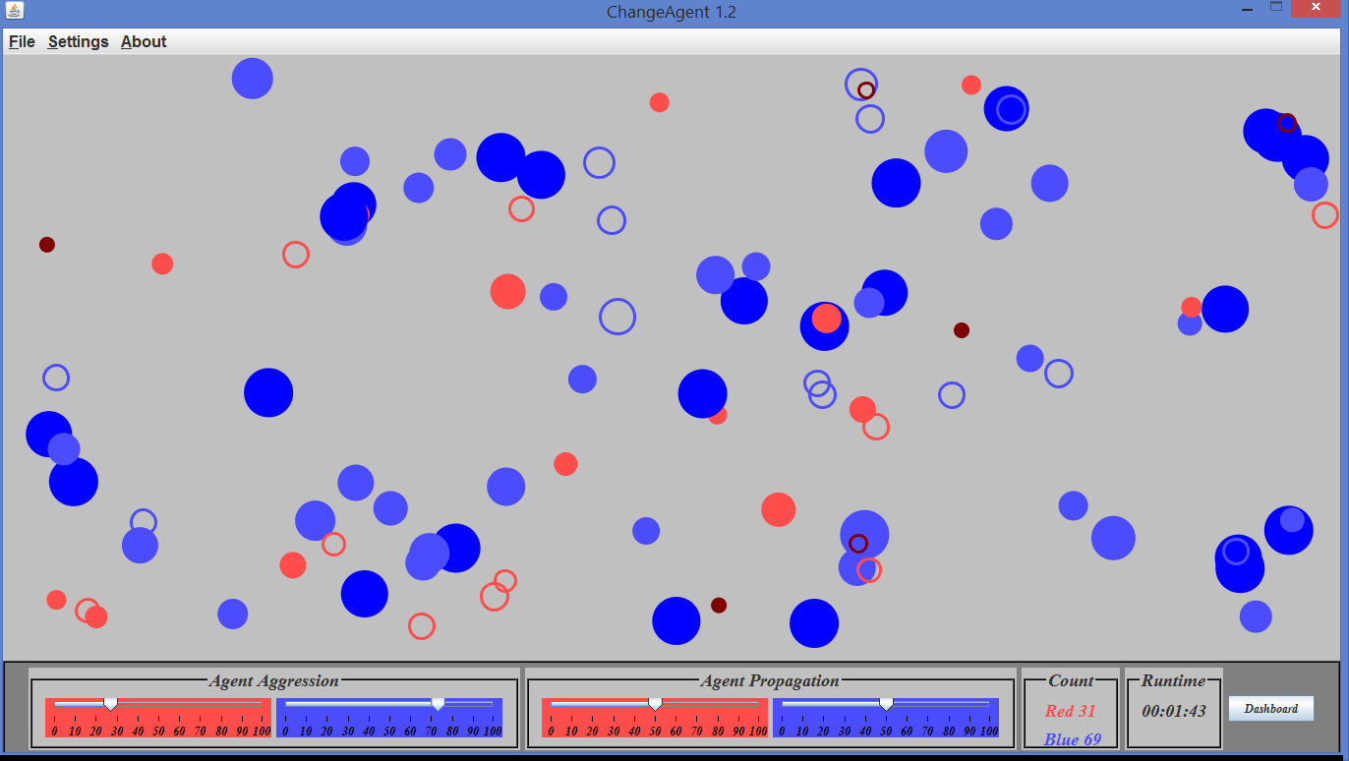

Figure 1. ChangeAgent screenshot. Blue group's aggression advantage has resulted in a large population of larger Agents. Empty circles indicate newly created Agents

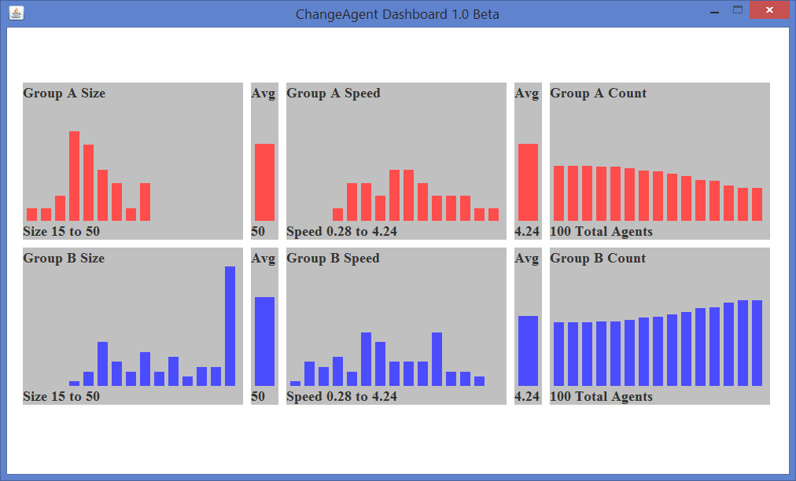

Figure 2. ChangeAgent Dashboard shows that Blue group's size distribution is shifted to the higher end of the range, its speed distribution is correspondingly slower. Blue group's population is increasing with its aggression advantage.

A sequence of ChangeAgent screenshots appended to the end of this document depicts the system responding to a series of operating parameter changes.

User Interface

Note: At present the user interface layout is not elegant. Development resources have been directed toward functionality rather than form.

When ChangeAgent is launched, the application enters full-screen mode as shown above and a popup menu provides system configuration options.

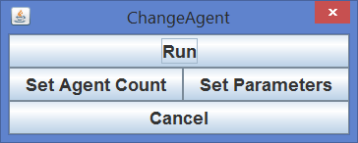

Figure 3, the startup popup menu.

The default parameters are as follows (sizes are expressed in pixels):

Start Size: 24
Minimum Size: 15
Lightweight Increment: 3
Maximum Size: 50
Heavyweight Increment: 5
State Change Increment: 1

Number of Agents

To set the number of agents, select Set Agent Count.

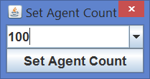
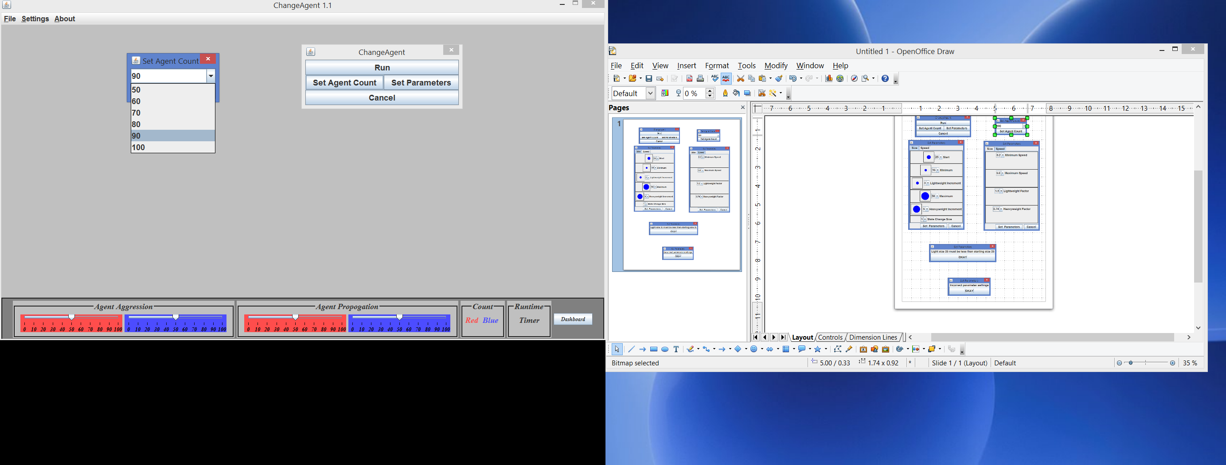

Click on the dropdown arrow →

Figure 4. The Set Agent Count popup menu and dropdown menu.

The dropdown menu is editable. Either select one of the options provided, or enter a value.

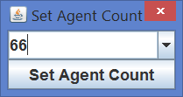
Figure 5. Enter a value for agent count.

Select Set Agent Count to close the agent count popup, which will return to the main menu.

Figure 6. Main popup menu.

Agent Size parameters

To set the agent size parameters, select Set Parameters. Select the dropdown arrow for a size parameter, the select from the range of values. The filled circle to the left of the chose parameter displays the choice.

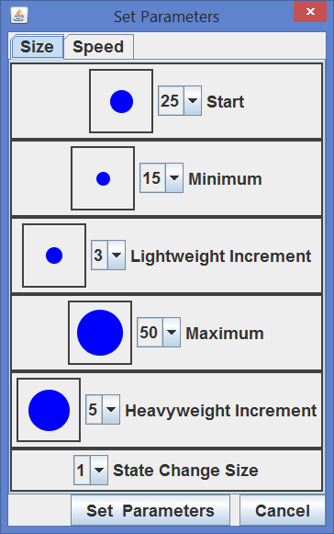
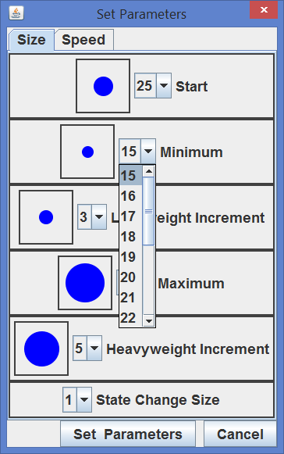
Figure 7. Set Parameters menu and dropdown for agent minimum size.

If a size parameter choice is inconsistent with another size parameter, for example, if the starting size is less than the lightweight size, an error message will be displayed.
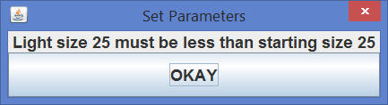

Figure 8. Error message for inconsistent parameter selections.

When the desired size parameters have been set, select the Set Parameters button. An error message will be displayed if one or more size choices in inconsistent.
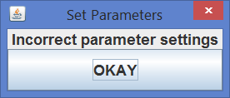

Figure 9. Error message warning of inconsistent parameter choices.

Agent Speed

To set the range of agent speeds and the lightweight and heavyweight speed factors, select the Speed tab from the Set Parameters menu.
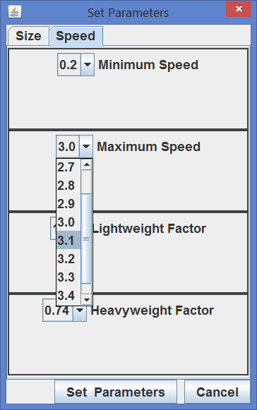
Figure 10. Select agent speed tab of the Set Parameters menu, showing dropdown for Maximum Speed parameter.

The agent speed values represent the number of pixels by which the agent will move each time the frame is refreshed. Note: When an agent is initialized, two random numbers between the minimum and maximum speed values are generated. One number is set for the agent's movement horizontally, the other number is set for the agent's movement vertically. In a future release, the system will generate a random number for the absolute speed, and a random number between 0 and 360 for the agent's compass bearing.

The lightweight and heavyweight speed values represent the factors by which an agent's speed is increased or decreased when the agent size is within the lightweight or heavyweight range.

When an agent's size is falls within its lightweight range, it speed will be increased by the chosen speed factor. If the agent size increases to a value larger than its lightweight size, the agent's speed will reset to its original value. Similarly, a heavyweight agent's speed is decreased by the chosen heavyweight speed factor, and reset when the agent's size is reduce below the heavyweight size.

Pause and resume.

The user may pause and resume the system model while it is running by selecting File → Pause and File → Resume from the menu bar.

Changing system parameters while the application is running.

The user may change agent size and speed parameters while the system is operating by selecting from the menu bar Settings → Number of Agents or Settings → System Parameters. These values may be reset either while the model is paused or while it is running. Certain changes will be given effect immediately, some changes will have a delayed effect.

Runtime size parameter changes are effected as follows:

Reset agent starting size: Newly propagated agents will be sized according to the updated setting.

Increase agent minimum size: All agents that are presently smaller than the revised minimum size will be eliminated and replaced by agents with the starting size. Agents that are within the lightweight increment will be rendered as such and their speed will be increased according the the current lightweight speed factor.

Decrease agent minimum size: Agents that are currently within the lightweight range will no longer be lightweights if they are larger than the reset lightweight range. These agents' color and speed will change immediately.

Increase or decrease lightweight increment: Agent color and speed will be changed immediately.
Increase agent maximum size: Agents which are at the maximum size will increase as they prevail over other agents. Agents which are no longer within the heavyweight increment will change color and speed immediately.

Decrease agent maximum size: Agents which are larger than the reduced maximum size will not increase if the agent prevails in the interaction. When an agent which is larger than the reduced maximum size loses an interaction, its size will be reduced. When the agent's size is reduced to a size less than the revised size, the agent's size will then be limited by the revised maximum size selected by the user. Agents which are within the adjusted heavyweight increment will change color and speed immediately.

Increase or decrease heavyweight increment: Agent color and speed will be changed immediately.

Increase or decrease state change size: Agent sizes will increase and decrease according to the revised setting immediately.

Changes to minimum or maximum speed: These changes will be applied to newly generated Agents.

Changes to lightweight or heavyweight speed factor: These changes will be applied to existing Agents as they change state from one category to the other.

Known Issues

File-> Open is disabled. The next revision will include a feature whereby regular samples of system data will be recorded in a SQL database file. This data will be analyzed in real time and displayed moving averages of system state, corresponding to parameter changes.

Settings → Number of Agents is presently disabled.

The sum of the Agent counts is sometimes one less than the total number of agents.

When the user resets the system parameters using the Settings->Set System Parameters menu, the dashboard is not automatically updated to reflect the change in system parameters. The user must close and re-open the dashboard to reflect the new system parameters.

The user cannot set the aggression and propagation rates before the system is launched.

Future enhancements and features

Improved User Interface Layout. The user interface layout will be improved.

Group aggression and propagation will be able to be set before the system is started.

Group population will be able to be preset by the user.

The bar graph number of bars and scale factor are hardcoded. A user interface to choose these parameters will be added.

System operation study examples.

The system parameter user interface and the operation controls may be used to investigate the system response to an ordered sequence of parameter alternatives, such as:

Increase one group's aggression in fixed increments, and observe the corresponding rate of population increase. Attempt to quantify the correlation between the aggression rate and rate of population increase. Repeat to determine the distribution of the population increase rate.

Perform the same as above with varying propagation rates. Attempt to quantify the relationship between population growth rate resulting from aggression advantages and propagation advantages.

Vary each operating parameter, attempt to determine various combinations that result in the same rate of population increase. Attempt to quantify the relationship between each operating parameter that results in a constant population growth rate.

Vary the Agent size parameters and Agent count in an ordered sequence, observing which combinations of size range and total population result in stable populations with both operating parameters set at random. Quantify the range of population shifts for various combinations.

Perform the same as the preceding study and determined if any combination of size range and total population result in one group eliminating the other, and observe the runtime resulting population domination.

Manipulate the operating parameters to cause the relative populations to adjust to a fixed ratio, the reset to random. Observe whether the populations remain within the ratio. Determine which population ratios result in elimination of the diminished group.

ChangeAgent 1.3 will have a system data sampling and database to assist in studies such as these suggested.
Appendix A

The following screenshots are taken from a ChangeAgent system simul with 100 Agents. The Agent starting size is 25 (pixels), the range is 15 to 50. The lightweight increment is 3 (Agents from 15 to 18 pixels are lightweight), the heavyweight increment is 5 (Agents from 45 to 50 pixels are heavyweight).

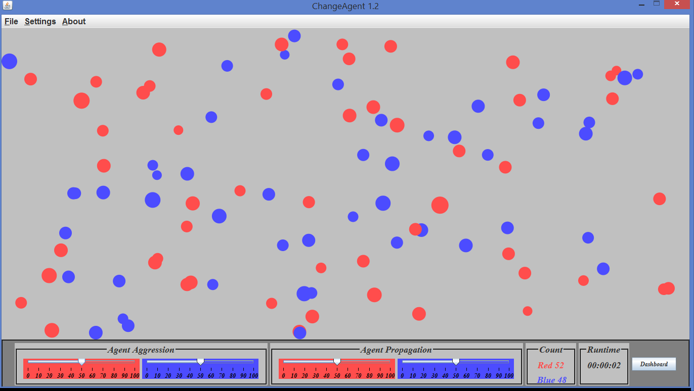

Figure 1. At system launch, Agents are nearly all the same size. Random distribution has resulted in a Red 52, Blue 48 population distribution. In only two seconds, Agents have interacted and changed state. Some are slightly larger, some are smaller.

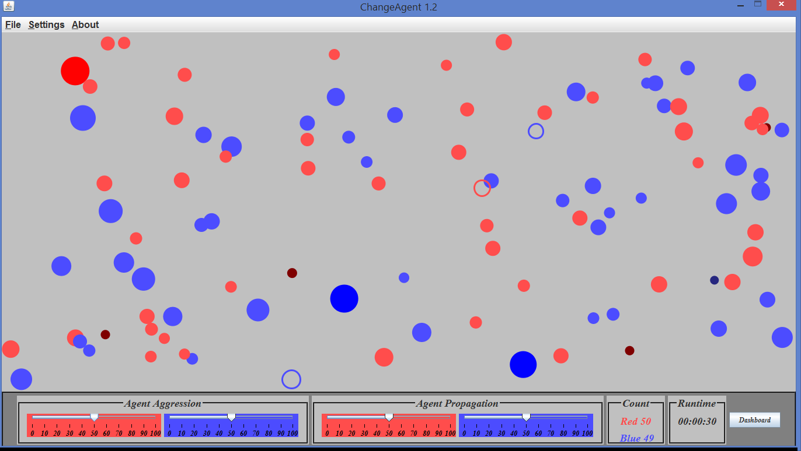

Figure 2. At 0:30, Agent size ranges from lightweight to heavyweight (denoted by the change in color.) New Agents have been generated to replace Agents eliminated which have changed state to smaller than the minimum diameter.

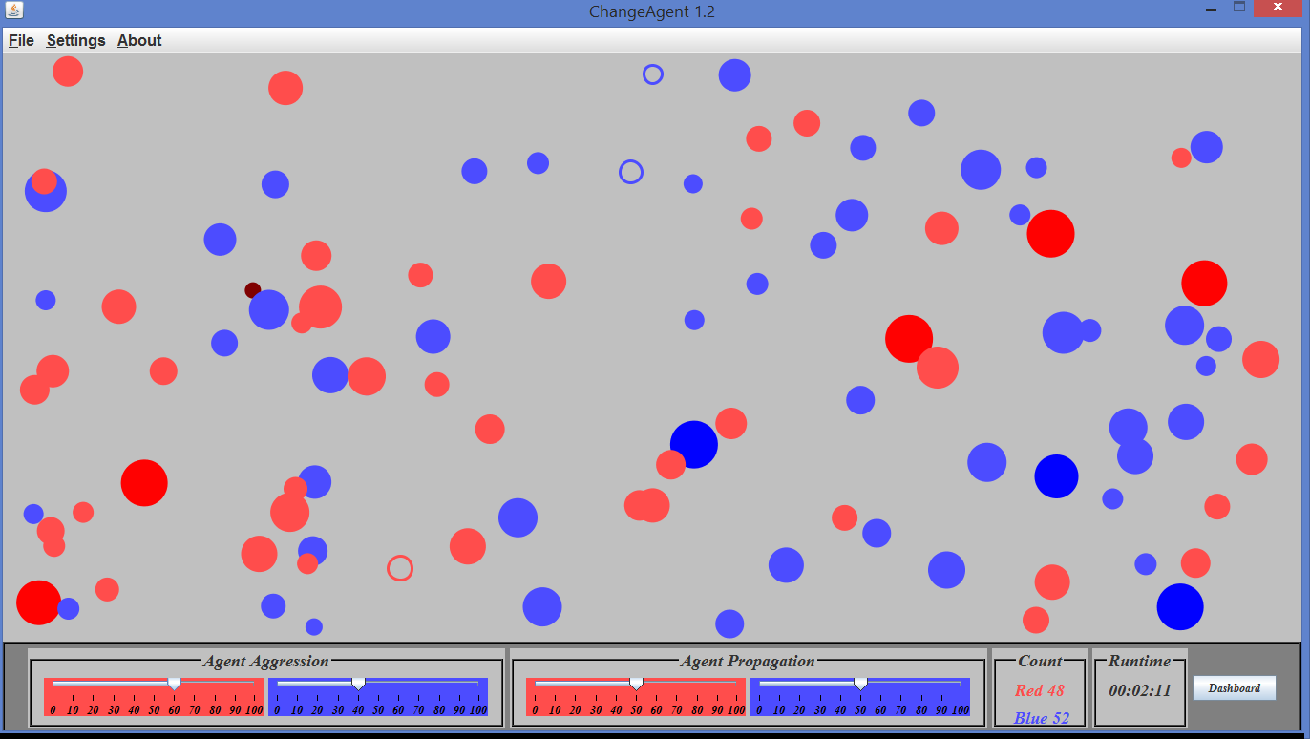

Figure 3. At 2:11, random Agent aggression has resulted in a population shift to Red 48, Blue 52. Red group aggression is set to 60%

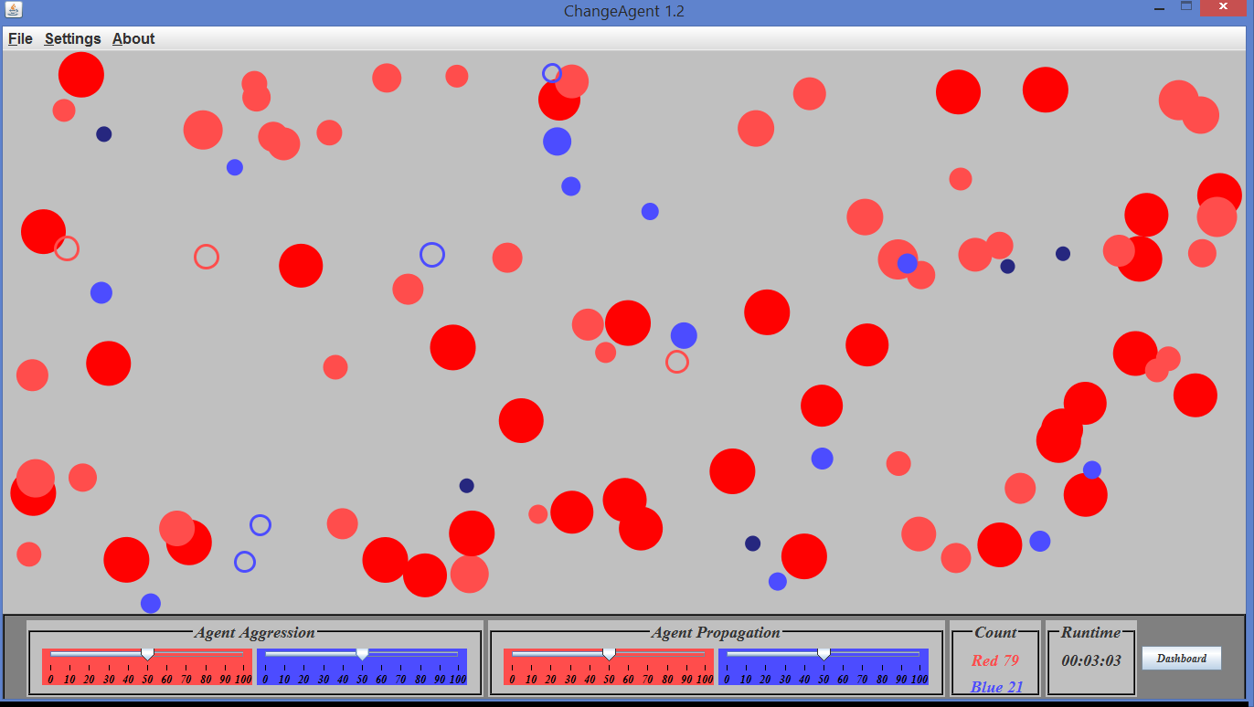

Figure 4. At 3:03, Red group's 60% aggression advantage (see Figure 3) results in a population shift to Red 79, Blue 21 in 0:52 seconds. Aggression is reset to 50 – 50. Note that Red group's size distribution is dramatically shifted to the maximum end of the range, nearly all Red Agents are heavyweights. Random group assignment (propagation) results in 3 new Blue Agents, 4 new Red Agents.

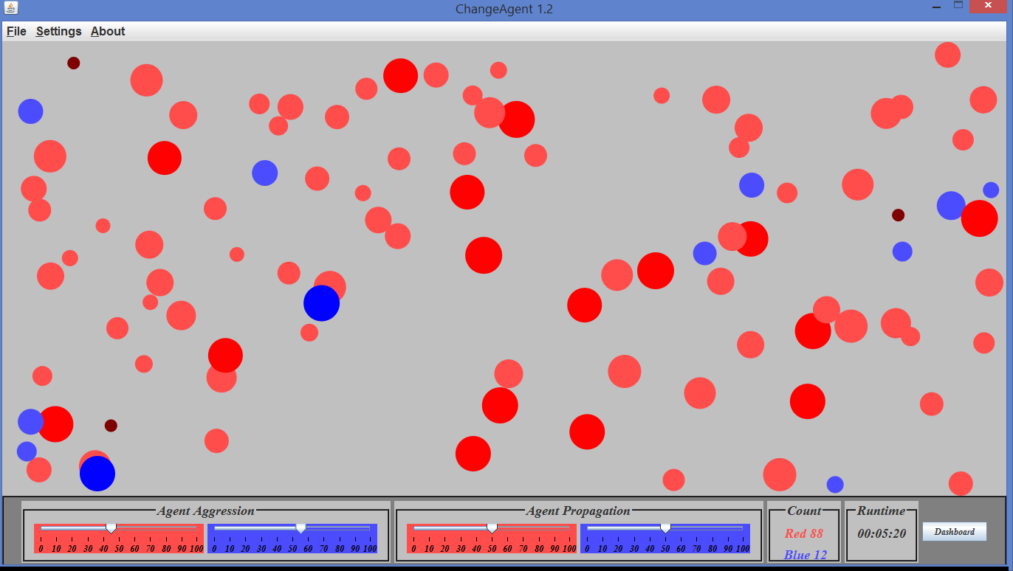

Figure 5. At 5:20, Red group's size distribution of heavyweights results in Red group's population continuing to increase, notwithstanding that aggression was reset to 50 – 50 at 3:03. The Red group heavyweights effect more Blue Agents, which has Red group's population to continue to increase. Aggression is set to Blue group's 55 – 45 advantage.

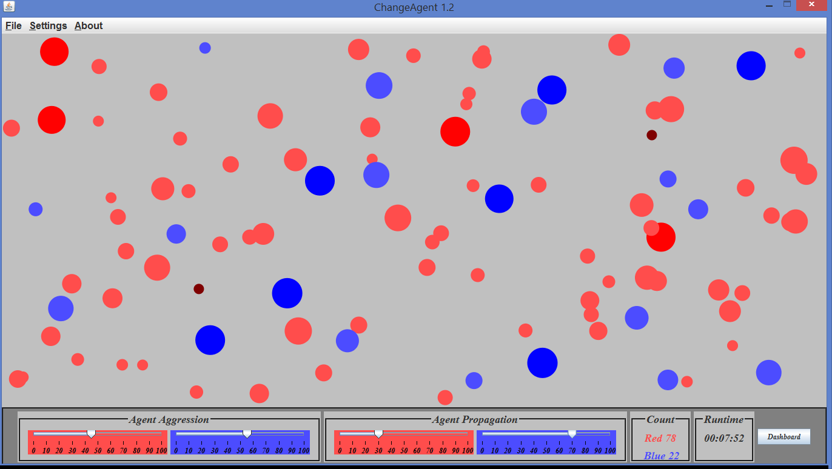

Figure 6. At 7:52, Blue group's slight aggression advantage (55 – 45) increases its population by 10, to from 12 to 22. Note again, that the population advantage results in most of the Blue Agents being heavyweights, Red group's size distribution is shifted to the low end of the range. This will be seen in the size distribution graphs on the dashboard (not shown). Propagation is reset to a 70 – 30 Blue Group advantage.

Figure 7. At 12:16, Blue group's 55% aggression advantage and 70% propagation advantage has restored group population nearly to parity. Each group's size distribution appears to be even. Blue group's propagation advantage is reset to 70%. Aggression remains at 50 – 50.

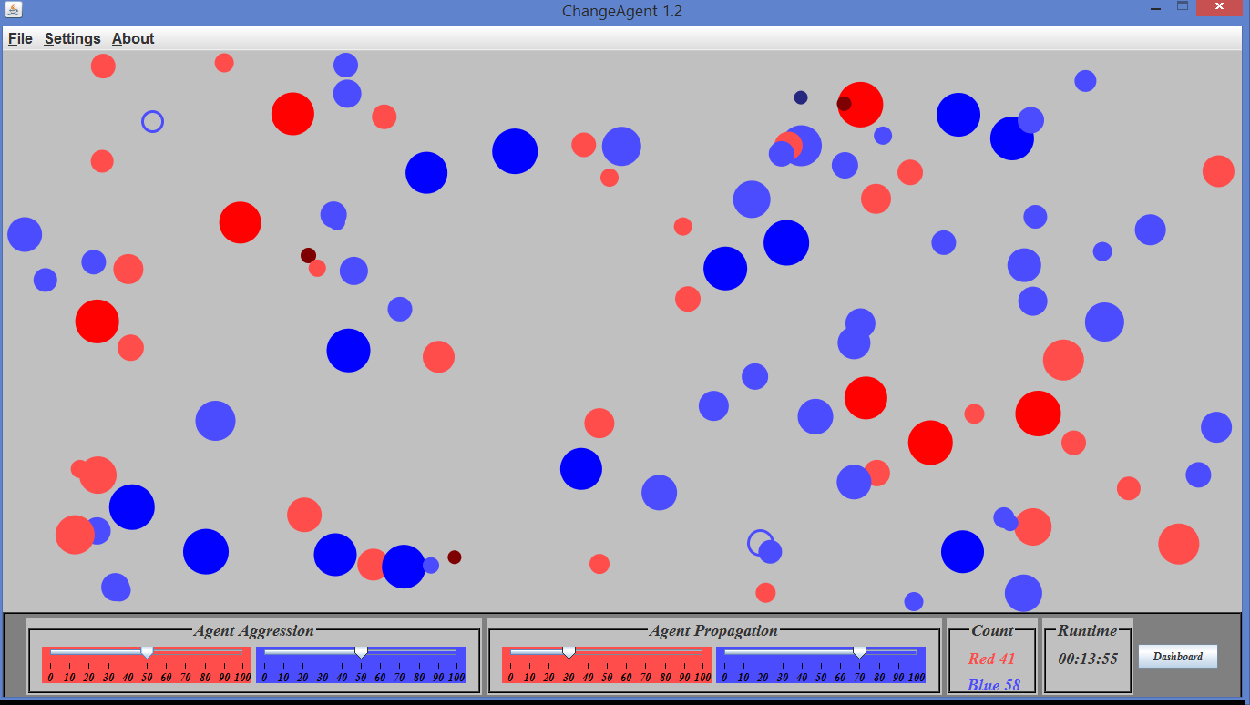

Figure 8. At 13:55, Blue group's 70 – 30 propagation advantage alone has increased its population by only 6 agents, in 1:39. Referring to Figure 3 and 4, a 60 – 40 aggression advantage for Red group, with propagation at 50 – 50, increased Red group's population by 31 Agents in :52 seconds. It is clear that aggression advantage increases group population at a much faster rate than propagation.

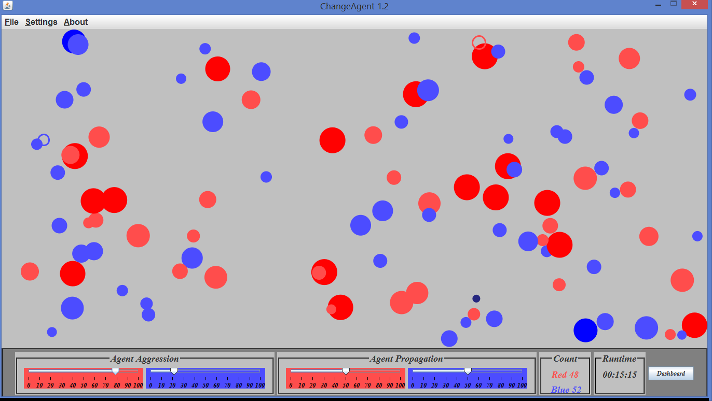

Figure 9. At 15:15, with nearly equal populations, Red group is given a large, 80% aggression advantage.

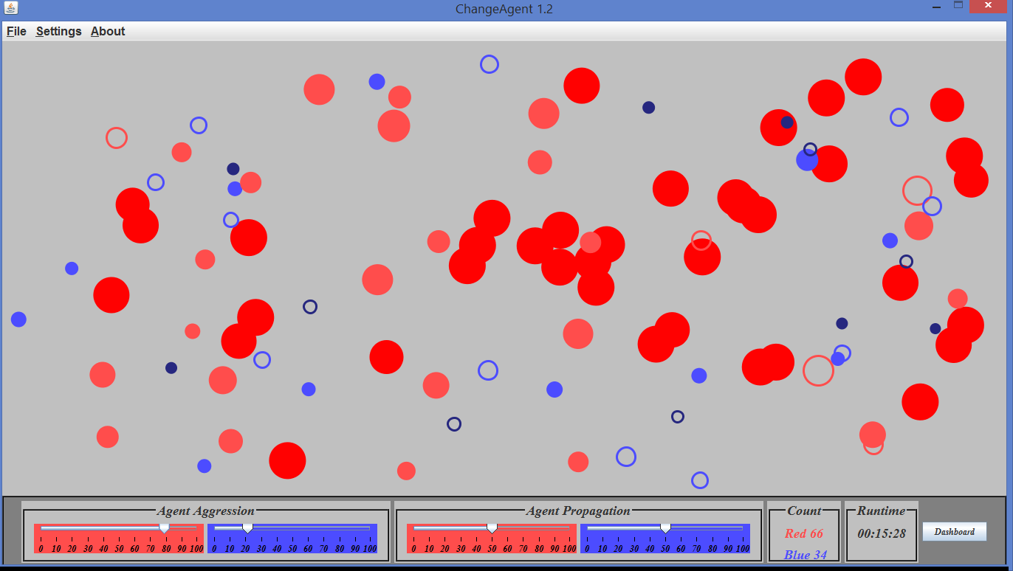

Figure 10. At 15:28, Red group's 80% aggression advantage increases its population from 48 to 66, in only 0:13 seconds.

Note: With propagation set at 50 – 50, nearly all of the newly generated Agents are Blue. This is clearly counterintuitive. Although ChangeAgent's group assignment algorithm has been rigorously tested, this may indicate a bug. After retesting, if the algorithm is found to operate correctly, an explanation for this curious phenomenon may be investigated by using ChangeAgent to rerun multiple tests under similar circumstances

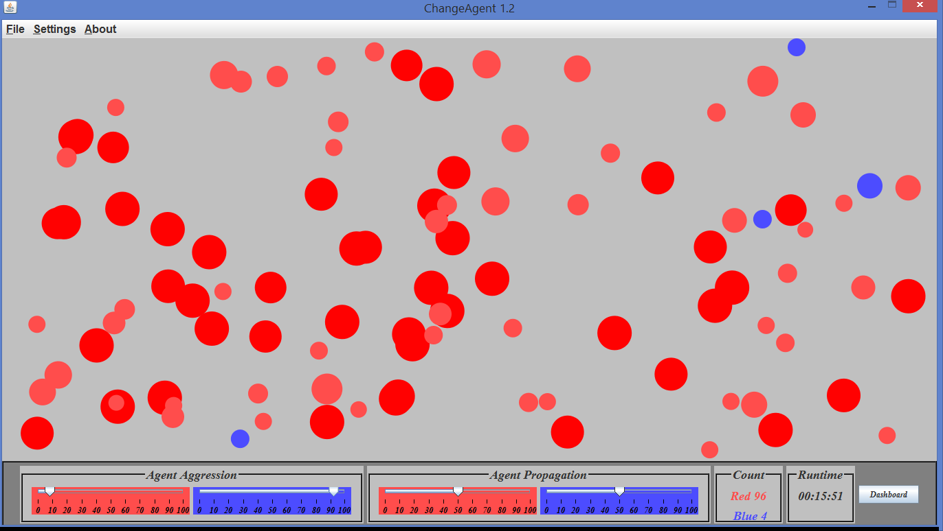

Figure 11. At 15:51, Red group's 80% aggression advantage nearly extinguishes Blue group in 0:36 seconds. Aggression is reset to Blue group's 90% advantage to see if Blue group can stave off elimination.

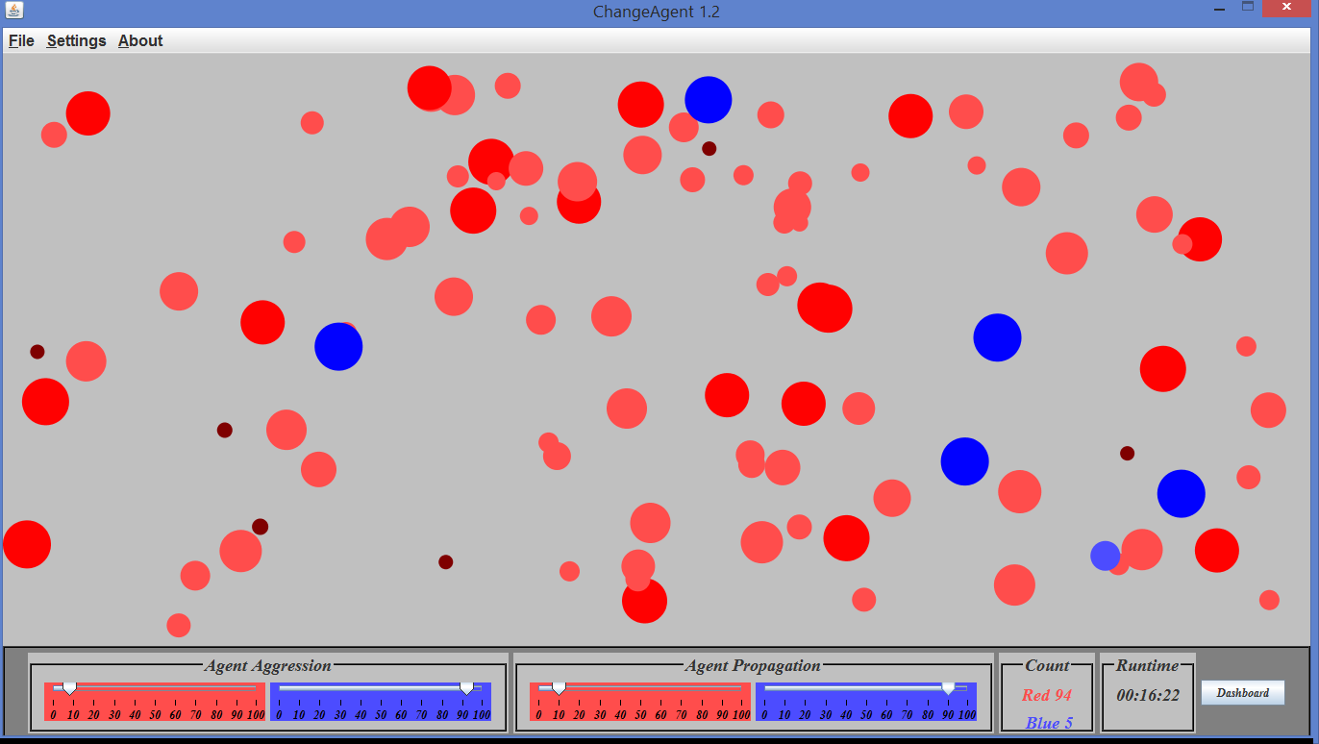

Figure 12. At 16:22, after 0:31 seconds, Blue group's overwhelming aggression advantage has increased its population by 1 Agent. However, 4 of its 5 agents are heavyweights. Blue group is given a 90 – 10 propagation advantage.

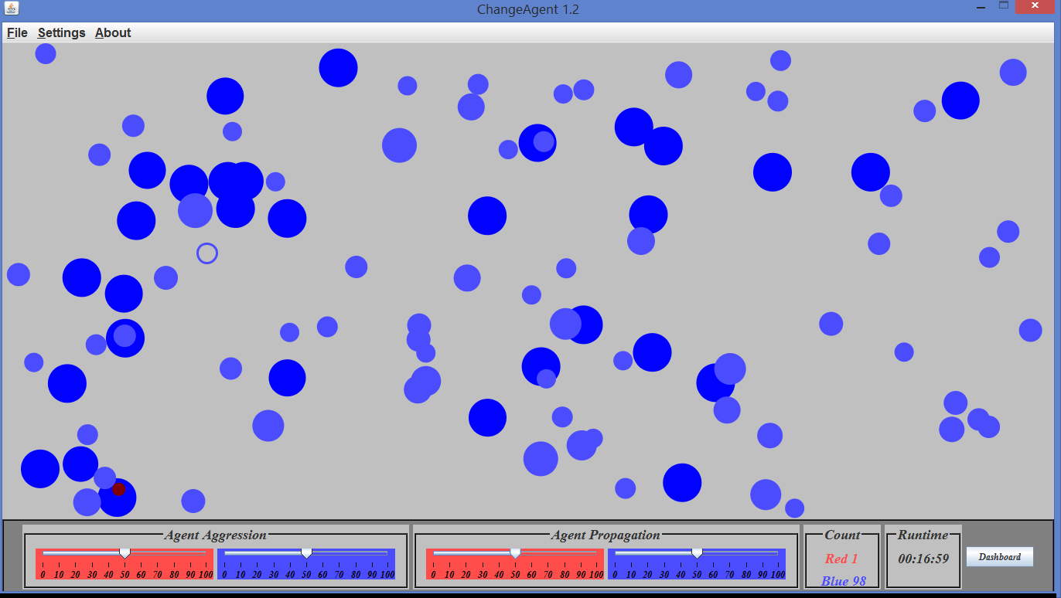

Figure 13. At 16:59, Red group has only 1 lightweight Agent. Red group's population has decreased from 96 to 1 in 1:08, by first giving Blue group a 90% aggression advantage, followed by a 90% propagation advantage. In an effort to stave off Red group's elimination, aggression is reset to a 90% Red group advantage. (Not shown, the screenshot had to be taken before the lightweight Red Agent was eliminated.)

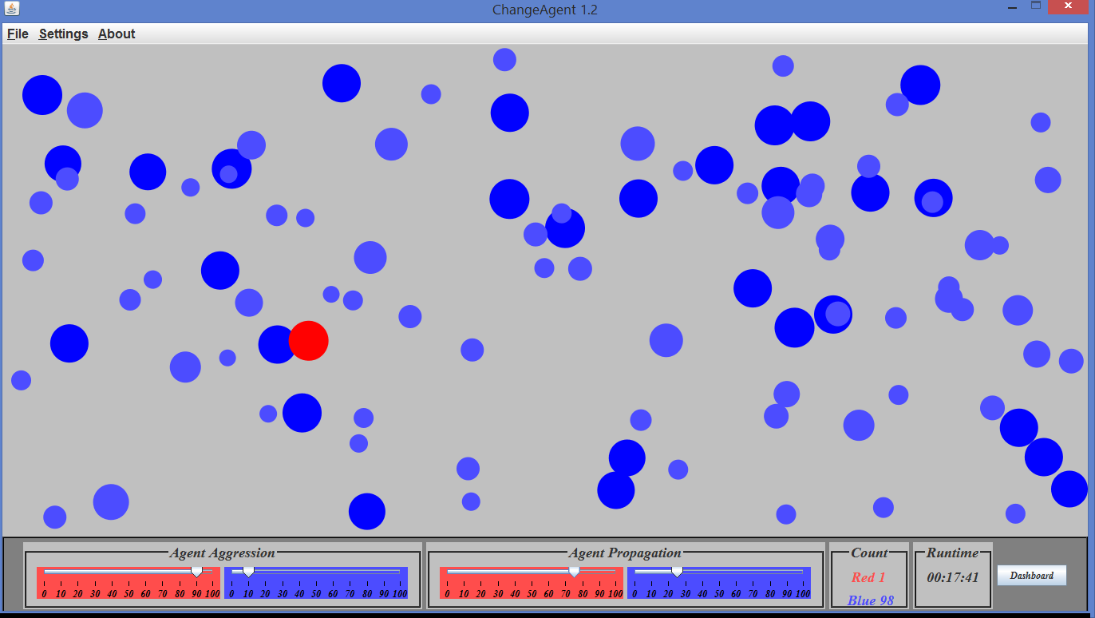

Figure 14, 17:41. Red group's sole Agent has become a heavyweight as a result of its 90% aggression advantage. It is given a 75% propagation advantage.

Figure 15, 19:32. After 1:51, Red group has gained only 1 additional Agent, however, both are heavyweights.

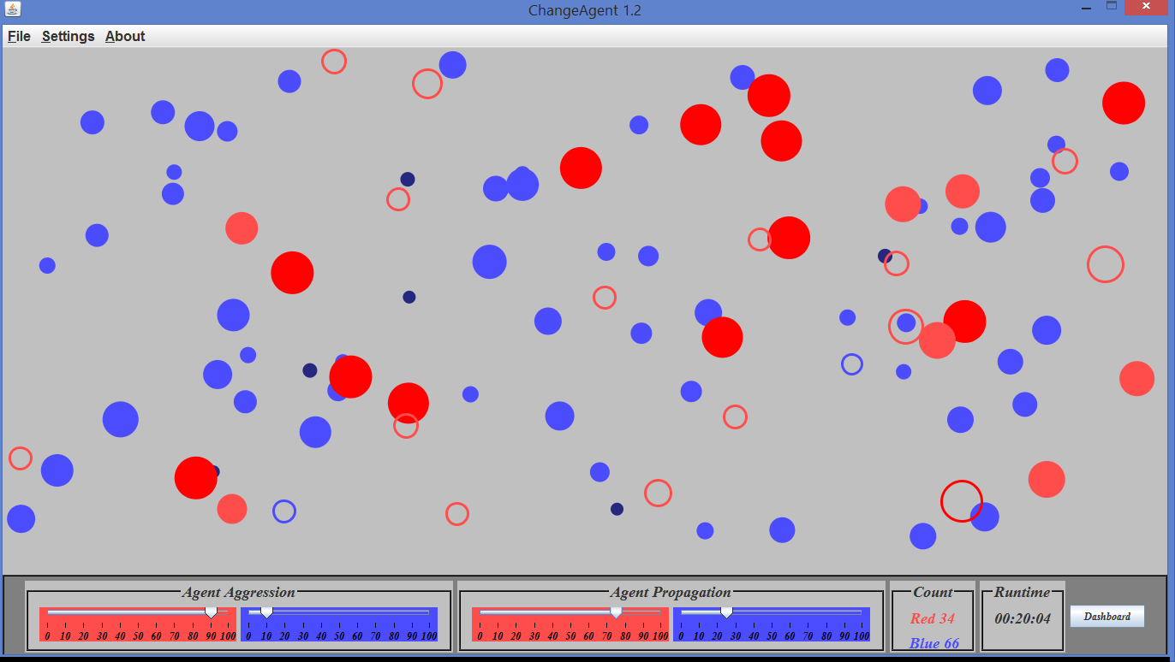

Figure 16. At 20:04, Red group's recovery is proceeding apace, with its large aggression and propagation advantages. Note that here, the newly generated Agents are overwhelmingly Red Agents.

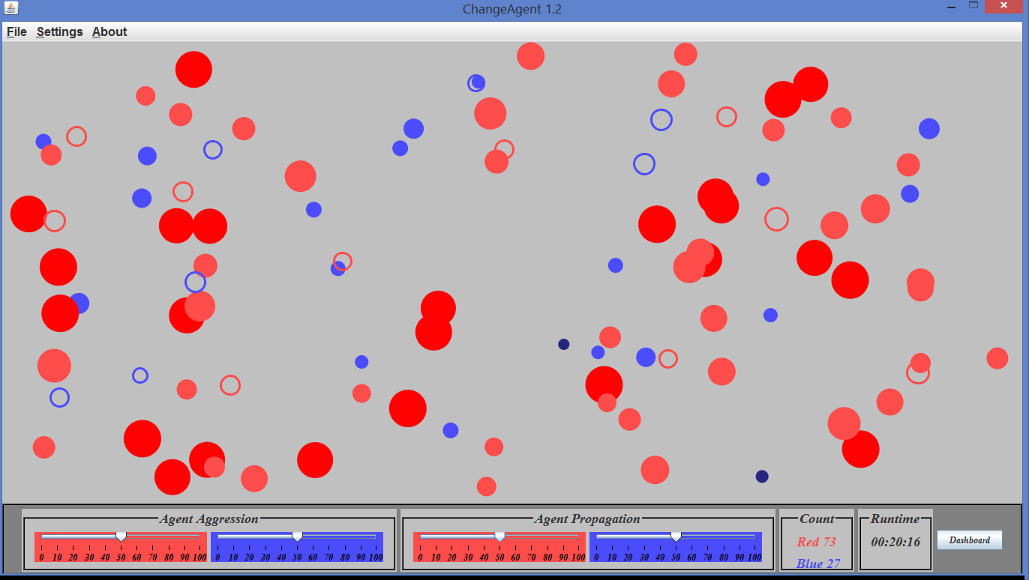

Figure 17. At 20:16, Red group has recovered from near extinction to a 73 – 27 population advantage. Aggression and propagation are reset to random.

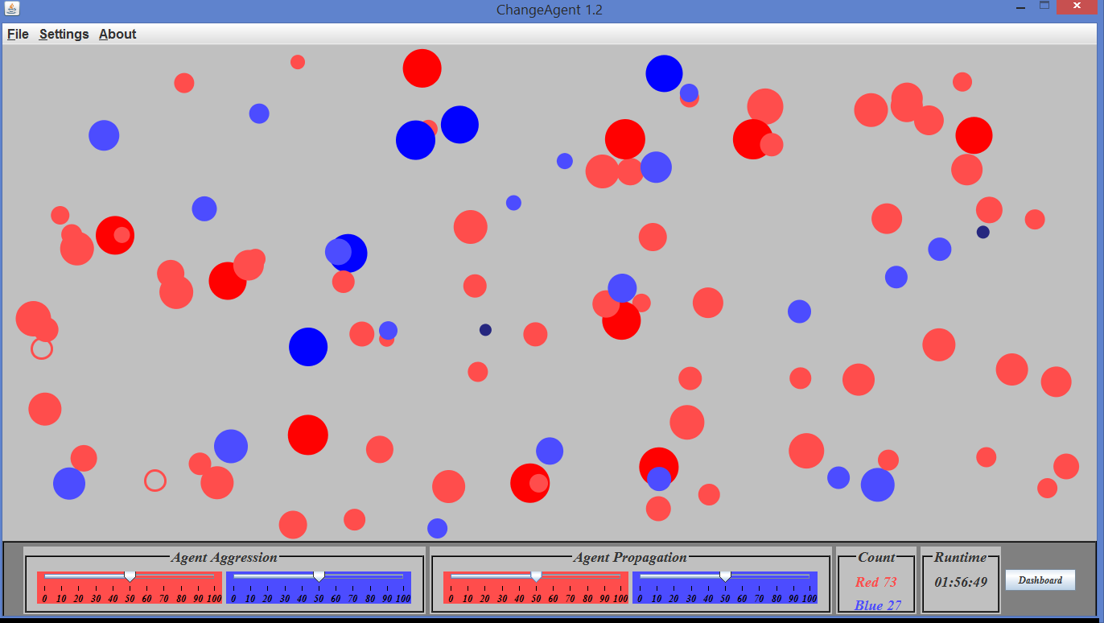

Figure 18. At 1:56:49, the populations have remained the same after 1:36:33. The system as achieved a nearly static state (it is coincidence that the populations are exactly the same as the previous screenshot, the populations have shifted with a 5 to 10 Agent range in the interim. It can be reported that at this writing, at 2:53:42 runtime, the populations are Red group 71, Blue group 29.

In ChangeAgent 1.3, regular sampling and recording in a database while allow the user to monitor the system status with finer detail.

